UNIT 4
TOPIC : BARRIERS TO COMMUNICATION .
SUBJECT : INTRODUCTION TO COMMUNICATION II

MS. RACHNA KASANA
B.A-JMC 2ND SEMESTER

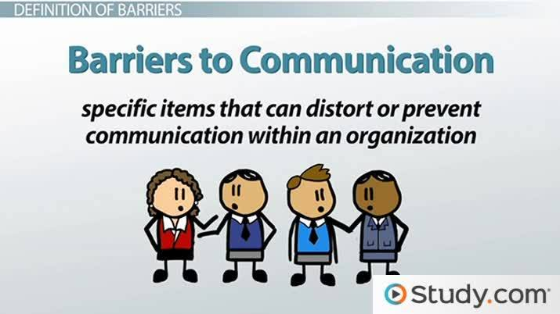

What is Communication?
Communication is an integral instinct of all living things. At its simplest, communication is any exchange of information between two entities. It can be observed to take place at the cellular level between microorganisms, and on a larger scale between members of a herd evading a predator. As modern humans living in a busy world, we rely on good communication every day to make our way through life. Every interaction we have with another person, from a raised eyebrow in a busy checkout lane, to an obscene gesture at another motorist in traffic, to the simple wave to your family as you pull out of the driveway in the morning, is a form of communication. Today, communication has gone from individual levels of conversing to mass communication. The most important aspects of communication are best understood when there is a lack of it. In the following pages, we will discuss different types of communication, common barriers in our daily communication, as well as strategies for overcoming them.
Good communication is not just a process of transferring information from one entity to another. It's an art of first listening or reading the information, comprehending it, processing it and then transferring it. There is a huge amount of effort that goes into communication. Gestures, tone of voice, body language and spoken language are some of the important aspects of communication. If the other person is unable to comprehend any of these factors, then the process fails.
[

Communication Barriers
There are many reasons why interpersonal communications may fail. In many communications, the message may not be received exactly the way the sender intended and hence it is important that the communicator seeks feedback to check that their message is clearly understood. The skills of Active Listening, Clarification and Reflection, which we will discuss shortly, may help but the skilled communicator also needs to be aware of the barriers to effective communication. There exist many barriers to communication and these may occur at any stage in the communication process. Barriers may lead to your message becoming distorted and you therefore risk wasting both time and/or money by causing confusion and misunderstanding. Effective communication involves overcoming these barriers and conveying a clear and concise message.
Some common barriers to effective communication include:
- The use of jargon. Over-complicated or unfamiliar terms.
- Emotional barriers and taboos.
- Lack of attention, interest, distractions, or irrelevance to the receiver.
- Differences in perception and viewpoint.
- Physical disabilities such as hearing problems or speech difficulties.
- Physical barriers to non-verbal communication.
- Language differences and the difficulty in understanding unfamiliar accents.
- Expectations and prejudices which may lead to false assumptions or stereotyping. People often hear what they expect to hear rather than what is actually said and jump to incorrect conclusions.
- Cultural differences. The norms of social interaction vary greatly in different cultures, as do the way in which emotions are expressed. For example, the concept of personal space varies between cultures and between different social settings.
A skilled communicator must be aware of these barriers and try to reduce their impact by continually checking understanding and by offering appropriate feedback.

Barriers to Communication by Category
- Language Barriers
Clearly, language and linguistic ability may act as a barrier to communication. However, even when communicating in the same language, the terminology used in a message may act as a barrier if it is not fully understood by the receiver(s). For example, a message that includes a lot of specialist jargon and abbreviations will not be understood by a receiver who is not familiar with the terminology used. As nurses, we are especially prone to making this mistake. We must remember to use language that can be understood by the receiver.
- Psychological Barriers
The psychological state of the receiver will influence how the message is received. For example, if someone has personal worries and is stressed, they may be preoccupied by personal concerns and not as receptive to the message as if they were not stressed. Stress management is an important personal skill that affects our interpersonal relationships. Anger is another example of a psychological barrier to communication. When we are angry it is easy to say things that we may later regret and also to misinterpret what others are saying. More generally, people with low self-esteem may be less assertive and therefore may not feel comfortable communicating - they may feel shy about saying how they really feel, or read negative sub-texts into messages they hear.
- Physiological Barriers
Physiological barriers may result from the receiver’s physical state. For example, a receiver with reduced hearing may not grasp the entirety of a spoken conversation, especially if there is significant background noise.
- Physical Barriers An example of a physical barrier to communication is geographic distance between the sender and receiver(s). Communication is generally easier over shorter distances as more communication channels are available and less technology is required. Although modern technology often serves to reduce the impact of physical barriers, the advantages and disadvantages of each communication channel should be understood so that an appropriate channel can be used to overcome the physical barriers.
- Attitudinal Barriers
Attitudinal barriers are behaviors or perceptions that prevent people from communicating effectively. Attitudinal barriers to communication may result from personality conflicts, poor management, resistance to change, or a lack of motivation. Effective receivers of messages should attempt to overcome their own attitudinal barriers to facilitate effective communication.

Overcoming Barriers
Most of the above mentioned barriers can be overcome by the skilled communicator. Obviously, bridging gaps in geography and communicating through disabilities are a topic for a different discussion. Below, we will look at some tools that can be used to bridge barriers in everyday communications.
- Active Listening Active listening is a skill that can be acquired and developed with practice. However, this skill can be difficult to master and will, therefore, take time and patience. 'Active listening' means, as its name suggests, actively listening. That is fully concentrating on what is being said rather than just ‘hearing’ the message of the speaker. Active listening involves listening with all senses. As well as giving full attention to the speaker, it is important that the ‘active listener’ is also ‘seen’ to be listening - otherwise the speaker may conclude that what they are talking about is uninteresting to the listener. By providing this 'feedback' the person speaking will usually feel more at ease and therefore communicate more easily, openly and honestly. There are both verbal and non-verbal cues that convey active listening. Non-verbal signs include smiling (if appropriate), making eye contact, nodding at appropriate times, and avoiding distractions. Theses non-verbal cues convey the message that you are interested in what the speaker has to say, and that your attention is fully invested. Offering verbal signs of active listening can also be useful. Reflecting on something the speaker has said by asking a clarifying question is a terrific way to do this. Paraphrasing involves finding slightly different words to repeat the main idea of the speaker, and is also great way to show active listening.

- Use Simple Language
It’s important to remember the audience that you’re speaking to, and use language that can be easily understood. Avoid using medical terminology or jargon when speaking to clients and their families. People are often intimidated by such language, and can be afraid to admit that they don’t understand the message being delivered. An important tool to use when speaking is to pause occasionally and ask questions to ensure that your message is being understood as intended. You may also allow the listener to ask questions to clarify any points.
- Give Constructive Feedback
- Remember that feedback was part of the communication chain we looked at on the first page. While the feedback that you give the speaker/sender may occasionally be negative, it is important that it be constructive in nature. The intent of the feedback should be to further the abilities of the speaker. This will strengthen the interpersonal relationship, and enhance future communications.

Summary
As living beings, we need to express and understand the expressions of others. Like it or not, human society thrives on communication. Civilizations have risen and fallen based upon how good they were at maintaining sound relations with the rest of the world. Communication is, indeed, the very lubricant that makes the machinery of human relations function smoothly. Therefore, the significance of communication cannot and should not be underestimated. Sometimes, difficult situations in life can be resolved by just sitting down and talking it out. Similarly, most personal, professional and social disasters can be averted by maintaining clear, appropriate and unambiguous communication. All we need is some effort on our part to identify and avoid barriers to effective communication to make our lives and the lives of those around us better.

Q/A
Q1: What do you mean by a barrier to communication? List all the important Barriers to effective communication?

